**Day 3 - API Integration Report - Meubel House.**

**1. Introduction**

This report outlines the process of integrating an external API into a marketplace project. The objective was to fetch product data, including images, from an API and store it in a Sanity CMS. It also includes adjustments made to Sanity's schema, migration steps, and tools used.

**2. API Integration Process**

1. **Fetching Data from API**:

* I fetched product data from an external API using Axios, a promise-based HTTP client.
* The API returned a list of products, each containing product details like name, image URL, price, stock level, and category.

1. **Handling Images**:

* The images were hosted externally (Unsplash). For each product, the image URL was fetched.
* I used Sanity's asset pipeline to upload the images to the Sanity media library by converting the image URL into a binary buffer using Axios.

1. **Importing Data into Sanity**:

* Once the images were uploaded, the product data (including image references) was created in the Sanity CMS using the Sanity client.
* Each product document was created with fields like name, description, price, category, and an image reference.

1. **Sanity Schema**:

* The Sanity schema was updated to support the product model, which included fields like id, name, image, price, description, etc.
* An image field was specifically added to reference the uploaded image in Sanity.

**3. Adjustments Made to Schemas**

**Schema Adjustments**

The original schema did not include a field for image references. I modified it to accommodate an image upload via Sanity’s asset pipeline. Below is the updated schema:

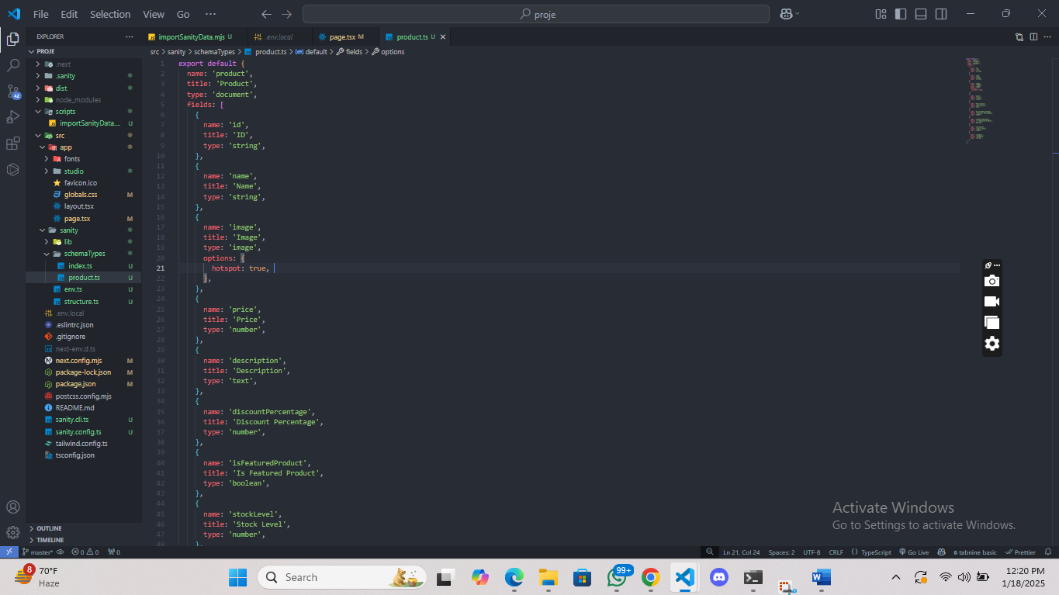

**Changes to Sanity Documents**

* **Image Field**: Added a new field image of type image to handle product images. This field stores the reference to the uploaded image.
* **Hotspot Option**: Enabled the hotspot option to allow for better image cropping and manipulation within Sanity Studio.

**4. Migration Steps and Tools Used**

**Migration Steps**

1. **Fetching Product Data**: Used Axios to fetch product data from the API endpoint.
2. **Uploading Images to Sanity**: Images were fetched via the URL and uploaded to Sanity using client.assets.upload().
3. **Creating Product Documents**: Once images were uploaded, I created product documents in Sanity using client.create(), linking each product to its respective image.
4. **Validation**: After the data was imported, I validated that each product's data was correctly displayed in the Sanity CMS and on the frontend.

**Tools Used**

* **Sanity Client**: To interact with the Sanity API and create product documents.
* **Axios**: For making HTTP requests to the external API and downloading images.
* **dotenv**: For managing environment variables securely (like Sanity API token).
* **Next.js**: For rendering the products on the frontend.

1. **Screenshots**

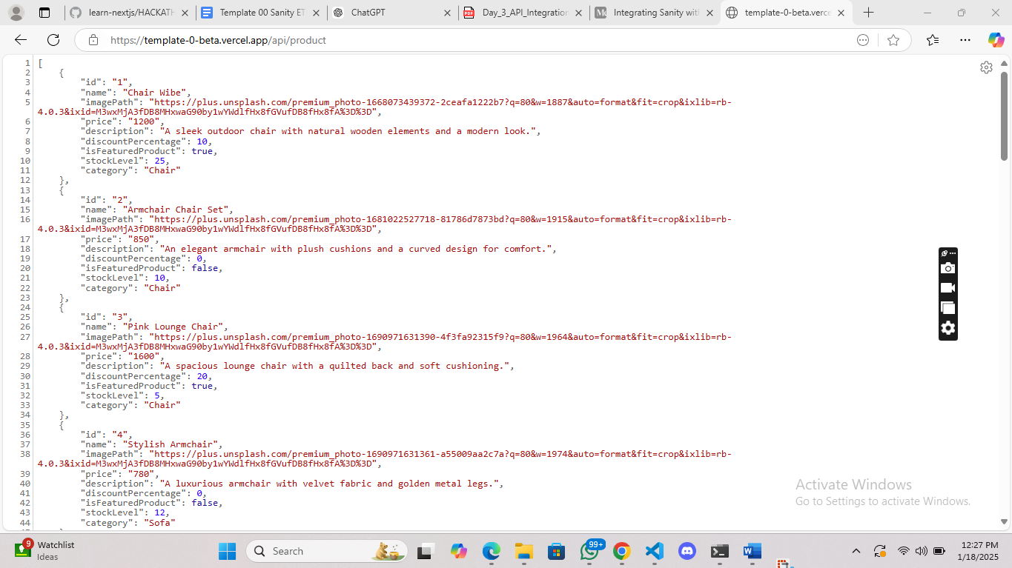

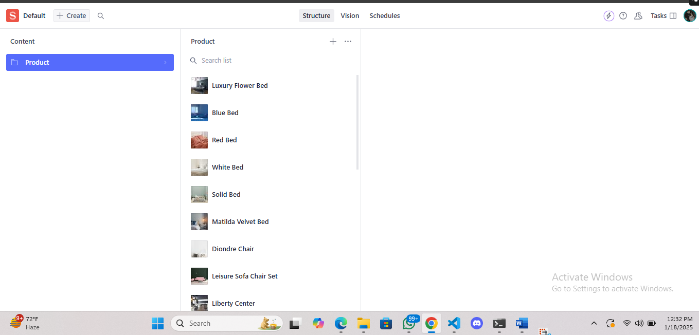

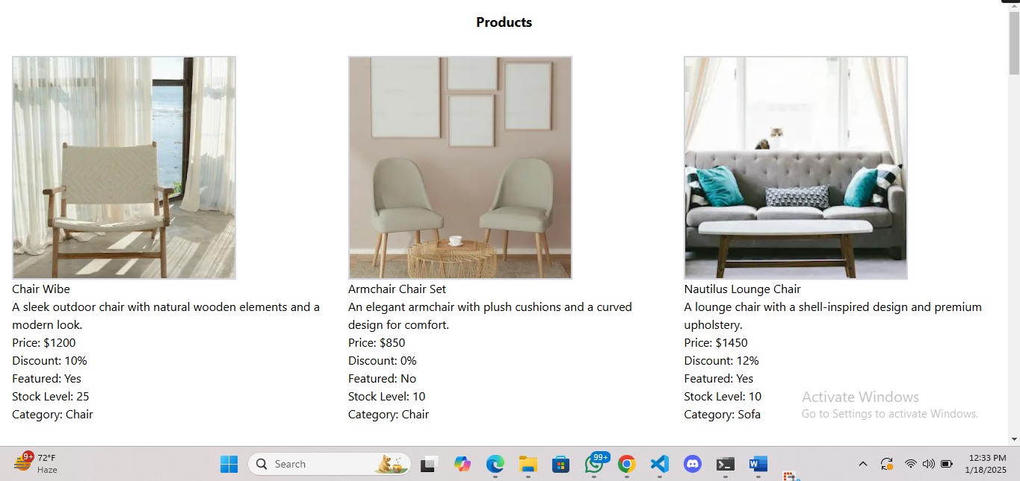

**6. Code Snippets for API Integration and Migration Scripts**

API Integration Code Snippet (Fetching Data and Uploading Images)

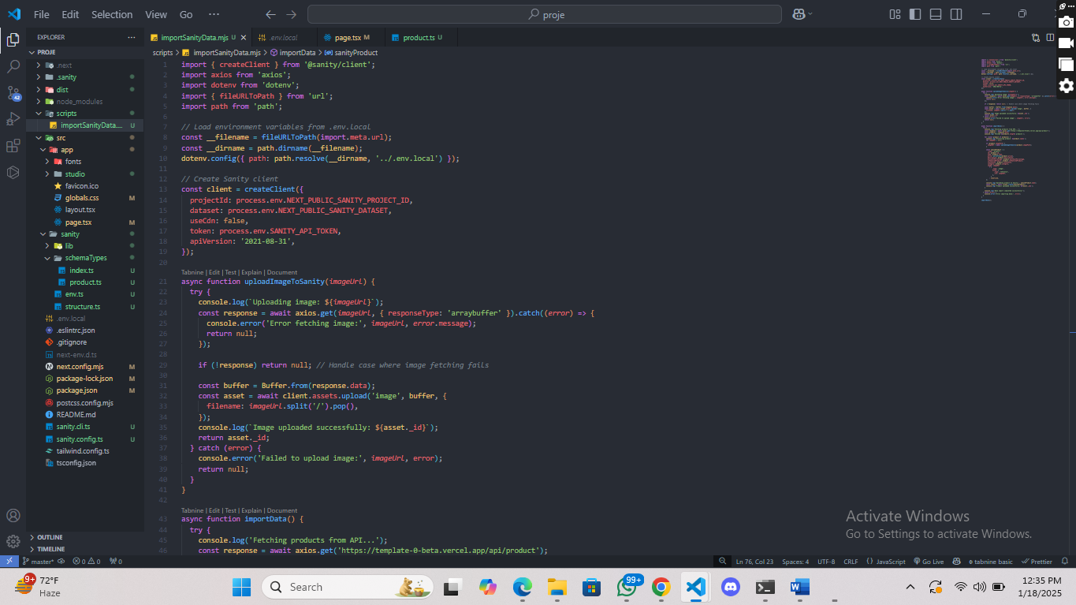

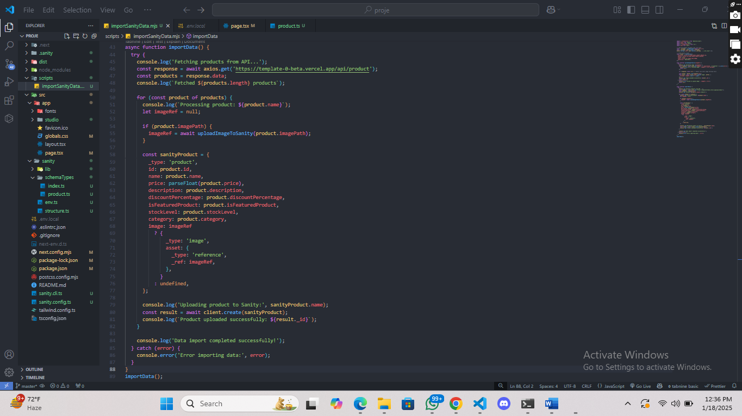

**7. Conclusion**

This report documents the API integration process, schema adjustments, migration steps, and tools used for importing product data into Sanity CMS. It also provides code snippets for fetching API data and uploading product information. The project successfully integrates product data from an external API, handles image uploads, and renders the data in a Next.js frontend.